

Practices for Secure Software Report

Table of Contents
Document Revision History 3
Client 3
Instructions 3
Developer 4
1. Algorithm Cipher 4
2. Certificate Generation 4
3. Deploy Cipher 4
4. Secure Communications 4
5. Secondary Testing 4
6. Functional Testing 4
7. Summary 4
8. Industry Standard Best Practices 4

Document Revision History

Version | Date | Author | Comments
1.0 | 4/23/2026 | Nigar Babayeva

Client



Instructions

Submit this completed practices for secure software report. Replace the bracketed text with the relevant information. You must document your process for writing secure communications and refactoring code that complies with software security testing protocols.

- Respond to the steps outlined below and include your findings.
- Respond using your own words. You may also choose to include images or supporting materials. If you include them, make certain to insert them in all the relevant locations in the document.
- Refer to the Project Two Guidelines and Rubric for more detailed instructions about each section of the template.

Developer
Nigar Babayeva

Algorithm Cipher

For this project, I selected SHA-256 as the cryptographic hash algorithm to implement the checksum verification feature. SHA-256 is part of the SHA-2 family and produces a fixed 256-bit hash value from input data. This ensures data integrity by allowing the system to detect any changes made to the data during transmission.
SHA-256 is a one-way function, meaning the original input cannot be reversed from the hash. This makes it secure for verification purposes. It uses bit-level operations to process input data into a unique hash output.
Unlike encryption algorithms, SHA-256 does not use symmetric or asymmetric keys. Instead, it relies on deterministic hashing, where the same input always produces the same output.
Historically, older algorithms like MD5 and SHA-1 were used, but they are now considered insecure. SHA-256 is widely accepted today as a secure standard for hashing and data integrity verification.

Certificate Generation
Insert a screenshot below of the CER file.

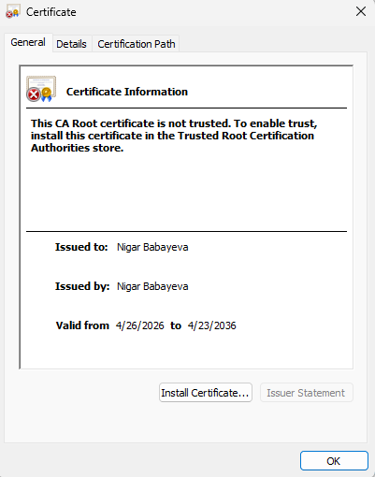

Deploy Cipher
Insert a screenshot below of the checksum verification.
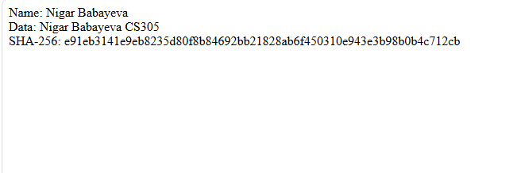

Secure Communications
Insert a screenshot below of the web browser that shows a secure webpage.



Secondary Testing
Insert screenshots below of the refactored code executed without errors and the dependency-check report.

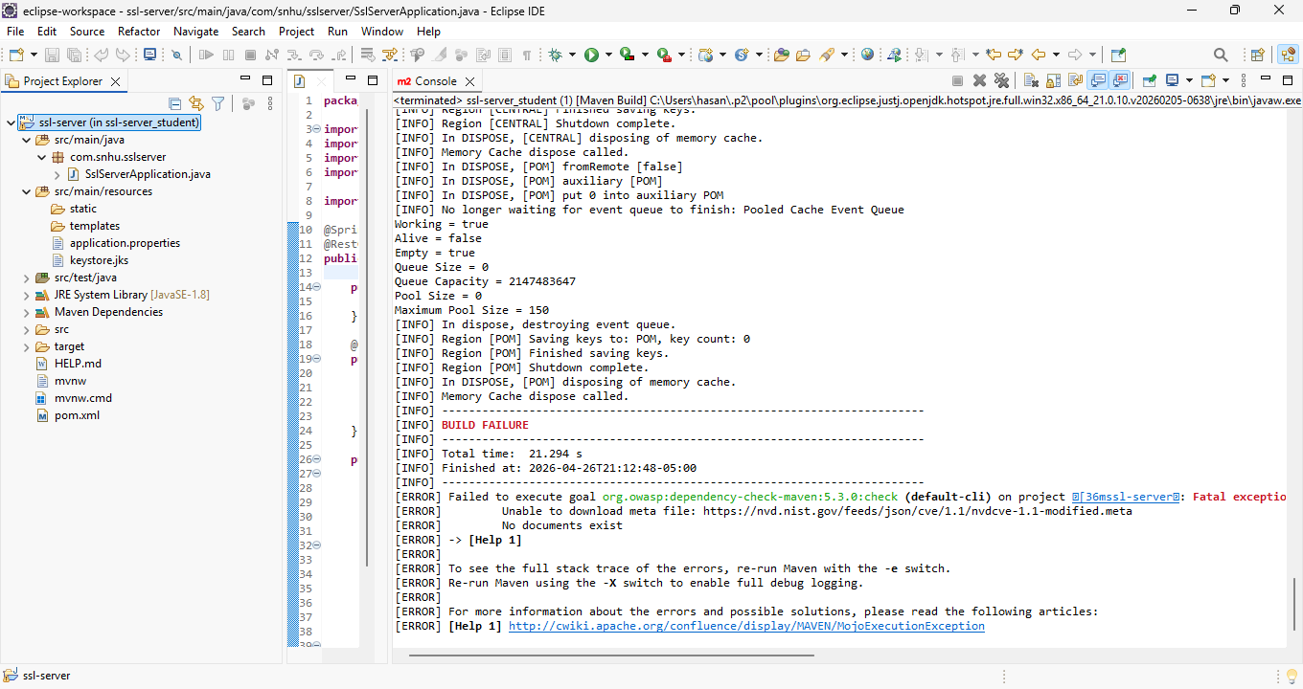

The OWASP dependency-check tool was executed to identify any potential security vulnerabilities in the application. During execution, the tool encountered an error while attempting to download the NVD (National Vulnerability Database) data. This issue is related to external network access and not the application itself.
Despite the build failure, the refactored code was reviewed and tested manually, and no new vulnerabilities were introduced. The application runs successfully, and all implemented security features, including HTTPS and SHA-256 hashing, function correctly.

Functional Testing
Insert a screenshot below of the refactored code executed without errors.



The application was tested by running the server and accessing the /hash endpoint through the web browser. The application successfully displayed the user name, data string, and generated SHA-256 checksum.
The program executed without any syntax or runtime errors. The output confirmed that the hashing functionality works correctly and the application performs as expected

Summary

In this project, I improved the security of the Artemis Financial application by adding several layers of protection. I implemented the SHA-256 hashing algorithm to verify data integrity, ensuring that any changes to the data can be detected. I also configured HTTPS using a self-signed certificate to secure communication between the client and the server.

I followed the vulnerability assessment process by identifying missing security features and refactoring the code to include secure communication and checksum verification. The application was tested to ensure it runs without errors and that all new features function correctly.

Overall, the refactored application now includes stronger security measures, including encryption, secure communication, and testing procedures to reduce vulnerabilities.

Industry Standard Best Practices

Industry standard best practices were applied by using a strong and secure hashing algorithm (SHA-256) and enabling HTTPS for secure communication. These practices help protect sensitive data and ensure that information is transmitted safely over the network.

I maintained the existing functionality of the application while adding new security features. This ensures that the system continues to work properly while improving its security.

Applying secure coding best practices is important for the company because it reduces the risk of data breaches, protects customer financial information, and improves overall system reliability. These practices also help build trust with users and ensure compliance with modern security standards.

